Design Document: Outcast
Last Update: 6th June 08
By: B .W-Husey

Notes: It is the requirement of all team leads to keep the Design Document up to date, as well as to log all changes in Perforce each time the document is updated.

Index

Overview
- Vision
- Background
- Team

Story
- Biographies
- Synopsis

Locations
- Key Locations
- Build Order

Resources
- Structures
- Creatures
- NPCs
- Placeables

Technical Information
- Perforce use
- Mantis
- Folder Structures
- Naming conventions
- Workflows

Overview

Vision (Rob)

Back To Top

Background (Ben)
The story takes place in the early part of Geralt's life, before he is established as a Witcher, during the reign of King Videmont of Aedirn (around 1190). It takes place in the Skellige Isles off the west coast, on an island ruled by jarl Harald. Many years ago, a monster attacked Harald's pregnant wife Morganna. In return, Harald went out to slay the monster, with the help of the gnome Shiltzen. As payment, Shiltzen demanded Harald's firstborn, but when Morganna gave birth, she bore twins. Seeing that the second child was monstrous, Harald gave that child to Shiltzen instead of the firstborn Astrid.
Back To Top

Team (Rob)
Director: Robert Trifts
Leads Writer: B W-Husey
Builders:
Technical Design: Deva Winblood
Art: Martin
Animation: Adam Anden
QA: John Lynch
Tools:

Teams Writers:
Design:
Technical Design:
Art:
Animation:
QA:
Admin & Tools:

Back To Top

Story
This section records the main plot and character elements used in Outcast. It does not track quests or detail subquests and plotflows. These are handled in the separate Story Flows Workbook.

Character Biographies (Ben)

Harald (Jarl of Kaer Karreg)
Description
Harald is around 6'6" in height, with the very aspect of a warrior. His frame is big, burly and well muscled, though he also has an ample belly from too much good living. His hair is black and wayward. His beard is streaked with grey, and combed long, with two braids in it, one from each cheek. His nose is fairly broad and broken, and his eyes sunken beneath heavy eyebrows. His eyes are a piercing blue.
Background
Harald is the local Jarl of Kaer Karreg. Though in his early fifties, Harald is a tough and brave, a hero after he slew a great monster many years ago.
When Harald was young, his pregnant wife Morganna was attacked by a monster. Though she survived, the monster pierced her belly, and there was great worry about her unborn child. Harald swore to avenge himself on the monster, and set out to kill it, but in his first encounter, the monster surprised him and left him for dead. The gnomish alchemist Shiltzen found him there, and agreed to cure him and help him slay the beast, in return for Harald's firstborn. With no other choice, Harald agreed.
Together, Harald and Shiltzen killed the monster, and Harald returned home a hero. Not long after, Morganna gave birth; to twins. The first child, Astrid, was fit and healthy, but the second, Hafnir was truly monstrous in appearance. When Harald saw his son, he realised that he would lose both his babies; for it was the custom of the land to leave deformed babies out on the hills to die. Instead, Harald gave Hafnir to Shiltzen, knowing that Shiltzen would have to leave Hafnir on the hills himself. This way, he kept Astrid.
Several years later, Morganna gave birth to another son; Sven, but the birth went badly and Morganna died. Harald eventually remarried to Gisla and had another son by her.
Peace reigned over the island for many years, until a spate of killings and attacks by monsters began on the villages. Rumours of a great beast drove away what little trade the island attracts, and unable to find the monster, Harald sent to the mainland to find a Witcher.
Harald himself is becoming certain this is the work of Shiltzen, that the priest has used his powers to discover Harald's subterfuge and bring an evil beast into the area that is preying on the people. Harald is unable to find Shiltzen, so he begins to persecute the non-humans, to punish them.
= Jarl Harald =
Morganna ‘the Fey’
Gisla
Astrid
Hafnir
Sven
Ragnar
Back To Top
Astrid (Daughter of Harald)
Description
Astrid is in her mid-twenties, with jet black hair, and green eyes. See concept art.
Background:
Astrid has had a largely untroubled childhood. Though many feared she would be fey like her mother, she was a confident child. When her father remarried to Gisla, the family became less close, but still remained happy. Though her father's relationship with Shiltzen seemed very sour, the gnome was favourable towards her, and on occasion he has taken her secretly to his house.
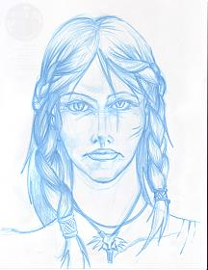
When Astrid was nineteen she was caught after dark by a group of drunken traders that were visiting the island. Caught by surprise, she was disarmed and pinned, while the traders prepared to have their way with her. Suddenly, a huge monster burst onto the scene, killing the traders. Though Astrid was certain she was to die, the monster left her unharmed. Instead, it briefly touched her hand. She saw intelligence in its eyes and it seemed about to speak. She swore then to come to the monster's aid should it ever need her.
Since that day, she has watched out for those that seek out the beast, and on some occasions, she has killed them. But her efforts to save the monster are in vain, for as she kills those that seek it, so its legend grows.
Back To Top

Hafnir (Son of Harald)
Description
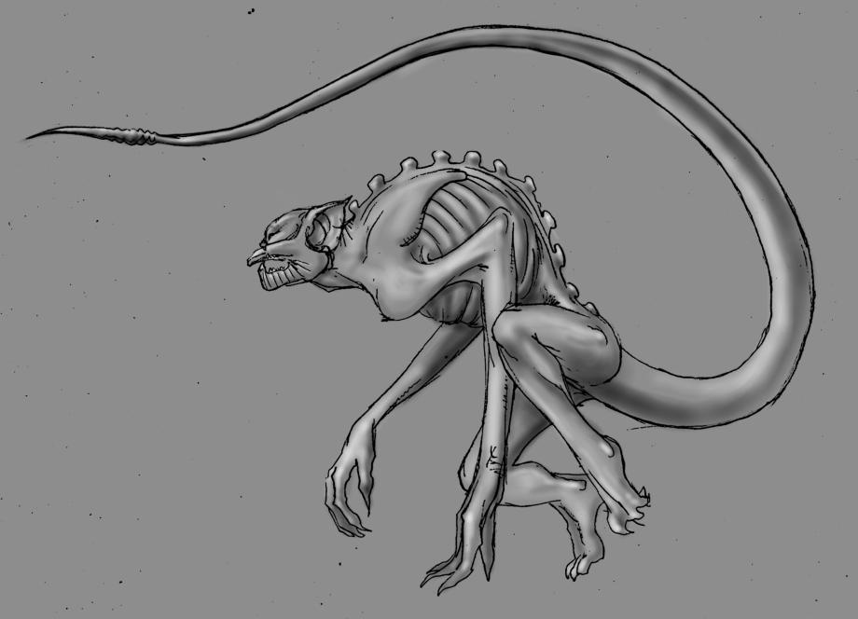
See concept art.
Background
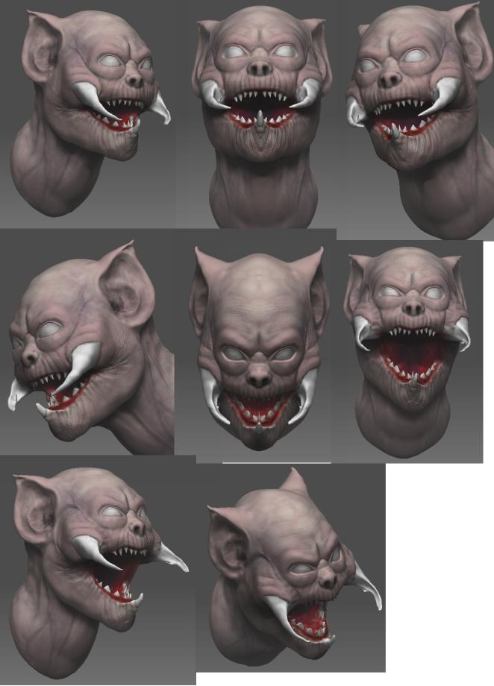
When Shiltzen took Hafnir in, he did not leave him out in the hills as custom dictated, but instead brought Hafnir up. Though Shiltzen was ugly and strange, and found Hafnir discomforting to look at, he was kind to Hafnir. He taught Hafnir about his past, and tried to 'humanise' Hafnir. He even brought Astid to the house so that Hafnir could see her, though Shiltzen never told Astrid his reasons or allowed her to catch a glimpse of her brother. For a large part, this seemed to work, but it was obvious that Hafnir had a vicious temper and a weakness for drink, so Shiltzen kept him always penned. For company, Shiltzen sometimes brought the elves to see him, but when Shiltzen's back was turned, the elves were often cruel and taunted Hafnir.
When Hafnir was about eighteen, a group of elves, seeking sport, brought a keg of mead and dropped it over the wall of the pen as a 'gift' for Hafnir. Quickly, Hafnir became drunk. With the elves taunting him, he became enraged, broke down the fence, and killed several of them. For several days he hid in the hills, confused by the blood he found on his hands when he sobered up. He never returned to Shiltzen, though he knew the gnome sought him out. Instead he went to find his sister, and would often watch her secretly. When the day came that she was attacked by drunken traders, Hafnir became enraged and came to her rescue. From that day on, he stayed clear of the settlements, though he would sometimes watch his sister. But try as he might, bounty hunts or chance encounters prevented him from remaining unknown to the islanders, and soon his legend began to spread.
Back To Top
Shiltzen (Gnomish alchemist/priest)
Description
Shiltzen is shorter than the average human, around 5' (1.6 metres), with a balding head and a very large nose. His hair is grey; his face heavily wrinkled. He is old; not at all nimble, and slightly bent over. See concept art.
Background
Shiltzen is a gnomish alchemist-priest. He was rescued as an orphan by the elves, and brought up by them. For many years he travelled the lands, seeking knowledge, until he came upon some old prophesies, one of them concerning the firstborn of the Lord of Kaer Karreg, that 'only the firstborn of Jarl Harald can ensure the survival of the original inhabitants of Skellige'. Determined to repay his debt to the elves by preventing their extinction, he travelled to Kaer Karreg, where he discovered jarl Harald dying on a hillside. As soon as he established who Harald was, Shiltzen made a deal with Harlad: to save his life and help kill the monster that struck him, in return for his firstborn. Faced with no choice, Harald agreed.
When Shiltzen came to claim Harald's firstborn (Astrid), Harald gave him instead the monstrous Hafnir, the second of the twins to be born. Shiltzen was faced with a dilemma. He knew the custom was to leave deformed babies in the hills to die, but determined to see the prophecy fulfilled, Shiltzen took Hafnir in.
It wasn't long before Shiltzen began to doubt the prophecy. Hafnir was a clearly a monster; a monster very like the one that Shiltzen had helped slay. What's more, Hafnir grew astonishingly quickly; he was man-sized in three years, and continued to grow beyond that. But is was also clear Hafnir was intelligent and sensitive, and Shiltzen grew to love him in his way. Shiltzen remembered his own lack of parents and his upbringing by the elves. He was kind to Hafnir, and worked hard to ensure Hafnir's upbringing would be calm and as close to human as possible. He invited Astrid to the house, so that Hafnir could see his sister, even though he was never allowed to meet her.
But Shiltzen also saw Hafnir's dark side, especially his temper; so he kept Hafnir always 'penned' in, unable to go where he pleased, until one dark day Hafnir broke out of the pen, killed several elves and went into the wild. Shiltzen spent several months looking for him, but finally gave up after discovering no sign of Hafnir.
Back To Top

Gisla (Wife of Harald)
Description
Gisla is a big women, nearly 6' tall, and with heavy bones and some extra meat on them. Next to Harald, she does not look small, unlike many others. Her hair is golden blonde, usually plaited, and her biggest joy. When free, it hangs almost to her waist. Her face is rosy, big cheeked, and full of good cheer. Her eyes are blue, and her teeth also uncommonly good. In her youth, Gisla was considered a rare beauty, though now she is in her late thirties and has broadened out more, particularly after the birth of her son Ragnar.
Background
Gisla is Harald's second wife. It is Gisla's ambition to see her son Ragnar become the Lord of Kaer Karreg, but it is clear that Harald will not put Ragnar before his older son Sven. Gisla was also Morganna's midwife, so she knows the secret that Hafnir was sent to his death at birth, instead of Astrid. She began an affair with Harald prior to Morganna's death, and seeing her opportunity to replace Morganna, she poisoned Morganna, inducing an early birth of her next child. Morganna died, but her son Sven survived.
Back To Top
Ylva (Priestess of Freyja)
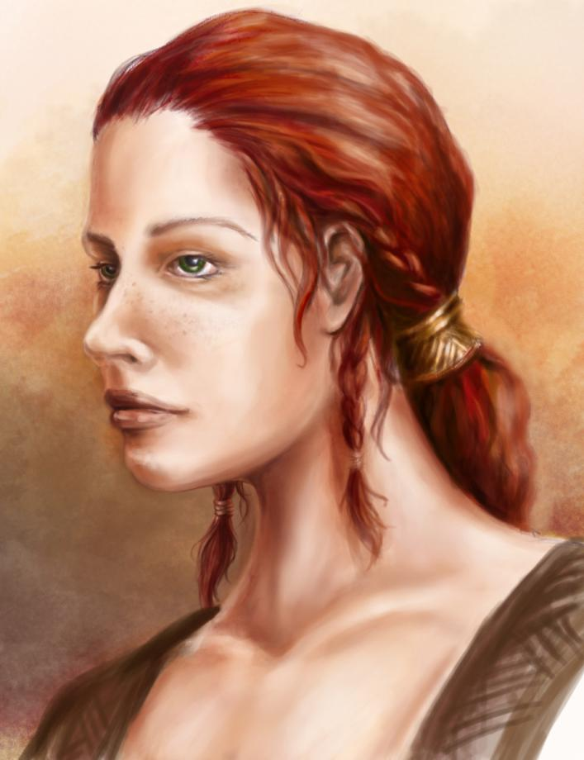
Description:
Ylva is in her late twenties, with rich red hair, green eyes and an almond shaped face. She is around 5’6” tall. Her skin is pale and her face unlined and slightly freckled; her hands are long and slender, the fingers rough from working with needles and ungents. She wears the robes of her faith.
Background:
Ylva is the daughter of an important Bonde of Hidarsfjall, and island to the north. She displayed great talent as a healer, and went into the temple of Freyja on Hindarsfjall until about 2 years ago. Ylva was sent from the temple to the Sanctuary in Lublow, because she was a very promising healer, and it was felt this rumoured curse could perhaps be turned aside by diligent worship of Freyja. She is only the second priestess of Freyja on Faroe, as the Sanctuary there is relatively new.
Ylva has no great love of the non-humans. She believes they hold to superstition, and this prevents the people of Skellige from truly embracing their faith. She has little truck with druids, and even less with the Wise Women that can be found in several villages. In her view, too much leniency and too many rights have been extended to the elves, but she does not blame the curse/killings on them, but on a lack of faith. She is fairly young, and full of firey faith. She blames almost all effects on the actions of the unfaithful themselves, and sees her role as one of healing the mistakes of others.
She has a fondness for Witchers, because she likes the way that they do not act as judges on sentient races – the role of gods and their clergy.
Style
Ylva unconsciously carries the arrogance of the better-born, even in her humbler role as a priestess of Freyja.
Back To Top
Ingrid
Ingrid is the young pregnant girl bitten in the opening cutscene. Her husband plays a supporting role and may be referenced/included in some conversations, particularly later in the game. She is a fairly central character early on, so if we need a new head, she should be blond, with shoulder length hair, and aged around 19. She would be considered quite pretty, and has an open and expressive face to match her optimistic outlook on life.
Style: Young and optimistic, but fearful of the future. She has an eager nature, and is easily excited. At first, she has the optimisim of youth; 'this isn't really happening' mentality. As the module plays out and Ingrid gets nearer to term, she becomes more despondent and fatalistic.
Back To Top
Urszula (Wise Woman)
Description
Urszula is old, perhaps in her early seventies, perhaps even more. Her life has been extended because she has some elven blood, and no one can really be sure how long she has lived in Han Cross.
Background:
Urszula is a hangover from times gone; a Wise Woman, more in the tradition of the elves. Han Cross has hung on to the tradition, as indeed have many of the villages of Skellige. She has an uneasy rivalry with Ylva.
Late on some nights, the elves even come to visit Urszula.
Style:
Urszula speaks like an old woman to a favourite grandchild, using terms like sweetie and dearie, but if her hard side is exposed, she is a formidable woman, drawing on her roots of elven magic and blood.
Back To Top
Kara (Spawn mother 1)
Three years ago, Kara was bitten by the beast in the fields. Her husband drove it off with a pich fork. She gave birth to a monster, and the Wise Woman, who was acting as mid-wife, held it while Kara strangled it.
Style: Down to earth. Has to get on with life, make the most of what's left of it. There's no point dwelling on the past, though no one can imagine what it was like to give birth to a monster. Only she knows what that really feels like, and she recalls the sweet Ingrid and cannot imagine the same fate for her.
Back To Top
Runa (Spawn mother 2)
Runa gave birth to a monster while in the fields. Her term came early, so no one was present. She fainted and the monster escaped. Later she told others she had miscarried.
Style: Angry at the world, and trusting no one. She is afraid her secret will come out, and this distrust has spread into her character. As a result she is losing her social network and alienating her husband, so they struggle to make ends meet.

Synopsis (Ben)
Opening:

We open with a cutscene; a meeting between Geralt and the impressive jarl, Harald. "It started with a regular contract, to find and kill a beast that was hunting the villagers of Lublow."
We see a pregnant woman on a wagon, and then nearby, a huge beast creeping down an alley. As the beast leaps out to attack the woman, another masked woman jumps out of the shadows to confront it. They face off, the woman with a sword, the beast standing, unsure. Geralt springs down the street to attack the beast, but as he passes the masked woman, she jumps at him and we see her sword slash down and a great gash open in Geralt's face. As Geralt falls, the beast springs on the pregnant girl and bites her, then flees. The masked into an alley and we are left with the pregnant girl screaming in the street, and Geralt lying in an increasing pool of blood. We zoom into his face, and the huge gash in his face fades into his scar as the background drops away.
"This time it was personal".

Act I: Kaer Karreg, Lublow & Woodland:
Geralt begins the story recovering in the Sanctuary of Freyja in Lublow. Ylva the priestess tells him he is healed, and that jarl Harald, who employed him, can be found up at castle Karreg. Both Harald and Ylva will also point Geralt towards Ingrid, the pregnant woman that Geralt was trying to save in the opening cutscene. Ingrid confirms that she also saw the Masked Woman.
As Ingrid begins to show signs of illness following the attack, Geralt tracks down another woman who was attacked many years ago by the beast. Her story is similar to Ingrid's, and she suggests that Ingrid may suffer the same fate as she did – to give birth to a monster. Ylva is unable to offer a cure for Ingrid, and in desperation, Ingrid and her husband beg Geralt to visit the Wise Woman in Han Cross. This opens Act II.
In parallel, Geralt investigates Lublow and its surroundings and takes on regular contracts. Astrid, Harald's daughter, fearing that her father will continue to blame the non-humans for the disappearances around Lublow, offers her help to Geralt, becoming available for several of the monster hunts as the game progresses.
Gisla, Lord Harald's second wife, also urges Geralt to find the monster and the Masked Woman he saw. The villagers confirm to Geralt that Gisla has hired Bounty Hunters to do the same task in the past, and Gisla confirms this, telling Geralt that the Bounty Hunters were killed or that one, a woman, disappeared. She asks Geralt to purchase swords quietly from the smith in Han Cross, in order to form a militia to defend Lublow from the beast. Geralt must be circumspect however; thralls are not entitled to bear arms, and Gisla would rather not have to explain herself to Harald until such an action has proven its worth.
Back To Top
Act II: Opens Han Cross & Southern Shores
Act opens with two cutscenes: the ferryboat from Lublow to Han Cross, and a cutscene showing a Forktail eating the body of a peasant in the fields of Han Cross. The villagers of Han Cross fear the beast has struck again. Geralt will reveal that the forktail is not the beast he seeks – but he may reveal that the body it took had been both long dead, and the victim of a sword slash. The body belongs to the steward of Harald, killed many years ago.
As Geralt continues to investigate Lublow and Han Cross, he discovers more cases of mysterious births. The Wise Woman of Han Cross will detail other mothers that gave birth to beasts, including one who went into the wild with her Spawn, and may be the Masked Woman. Several of these leads give rise to Spawn quests; boss monster style fights where Geralt (and potentially Astrid) face a powerful foe.
The common folk blame this apparent curse on many varying causes; straying from the gods, adultery, a curse from a druid, and other variations. The women themselves have either kept quiet or hidden, or have been spurned by the commoners. As Geralt begins to unravel the individual tales, he finds the common link in all of these cases is that the mother was bitten by a specific beast whilst pregnant. Many of the monsters that were subsequently born are still at large.
Geralt will have deduced there is more than one monster: they kill on some occasions, and on others only bite the pregnant women.
Geralt is forced towards making a choice between the old ways of the Wise Woman and the zeal of Ylva of Freyja, but it starts to become clear that Ingrid cannot be healed by either of them. In the meantime, more theories are presented as to what is happening around Lublow. Harald believes it is down to the gnome Shiltzen, who leads the non-humans. He presents as his reason a story of how some of his karls defiled an elvish holy site when they got drunk. The beast was Shiltzen's revenge, and the Masked Woman is one of the elves.
Astrid tells Geralt that the elves are not at fault and that she also believes Shiltzen to be blameless. She has grown to know Shiltzen well, and cannot understand her father's hatred of the gnome. A good relationship will also prompt Astrid to reveal the whereabouts of the elven leader Ellevander. If Ellevander has already been discovered, he will have revealed to Geralt that he saw the Masked Woman kill one of the Bounty Hunters. If not, he does not do so.
Gisla awaits the delivery of the swords she requested of Geralt, but whether Geralt accepted or not (or failed the quest), Gisla disappears for the rest of the Act. Instead the Hunt Master (or a bonde) fills her shoes (as well as performing more regular functions). The Hunt Master reveals to Geralt that Gisla looked very fearful before she disappeared.
The Act closes after Geralt has killed at least two of the Spawn. At this point, Harald tells Geralt he (and Gisla) has seen the heads that Geralt brought in, and they bear an uncanny resemblance to the monster Harald slew so many years ago. Harald tells Geralt he must get Shiltzen's wereabouts out of Astrid, for the gnome has committed some devilry – perhaps even brought about the original monster he helped to kill. Astrid agrees to take Geralt to find Shiltzen; either because she is convinced he can cure Ingrid, because of her strong relationship with Geralt, or because she needs to demonstrate to Geralt that her father's claims are false.
Back To Top
Act III: Opens Shiltzen's location
Cutscene to be determined.
This Act has two parallel threads: one dealing with Shiltzen, and the other with Gisla.
Shiltzen's thread: It seems there is no hope for Ingrid, except to turn to the gnome Shiltzen. But here Geralt is faced with a dilemma: Does Geralt believe jarl Harald and want to kill Shiltzen, or does he believe Astrid and believe the beast has another cause? Shiltzen is adamant that all those years ago he helped Harald slay the monster and has nothing to do with this new beast. To prove it he offers a cure for Ingrid, stating that what has struck her must be some kind of lycanthropic disease.
The potion fails to work. Now Shiltzen becomes convinced it is something far rarer. He begins to muse that it might be hereditary or parasitic, since there is a clear link between the original monster and the new. If Geralt allows him to survive, Shiltzen will tell the story of a Prophecy, that the firstborn of Harald would be the saviour of the original inhabitants of Skellige. He tells how he was given Hafnir, Harald's deformed son. Shiltzen admits to bringing up Hafnir, hoping that somehow this would save the elves from extinction. Shiltzen tells how Hafnir escaped to become the very monster that has been haunting the island. Desperate to prevent harm to Hafnir because of the Prophecy, he tells Geralt that Hafnir is Astrid's brother. Geralt must then decide whether Shiltzen should live or pay in some way for his part in this affair. Killing Shiltzen however will seriously damage Geralt's relationship with Astrid.
Gisla's Thread: In parallel, Gisla has returned to Kaer Karreg. Gisla has seen the heads that Geralt brought in, and has deduced that they must be the offspring of Hafnir. She tells Geralt that she saw the boy at birth, as she was the midwife present at the birth. She remembers that the gnome Shiltzen took him away. The heads that Geralt has brought in, and the features of Hafnir, were identical.
However Geralt may also have discovered some of Gisla's own history from Ellevander, the leader of the Elves. Ellevander may have revealed that Harald's steward was murdered long ago when he discovered Gisla was buying poisons from a trader. Ellevander will reveal that he was commissioned to kill the steward. It seems that Gisla may have poisoned Morganna, Harald's first wife, in order to take her place. Gisla's defence is that Morganna's blood was tainted when she was attacked by the original monster. She knows this because she saw Hafnir, and she feared that Sven, Morganna's second son, could also be a beast.
Geralt may attempt to report Gisla, leave her in place or kill her. This will affect who becomes lord at the end of the game.
Geralt returns to Harald with the knowledge that Hafnir is Harald's son. With this presented to him, Harald admits that he gave the wrong child to Shiltzen. It becomes clear to Geralt that Astrid is the one that is crucial to the prophecy, and not Hafnir. Hafnir however, is still nowhere to be found.
Geralt may also opt to tell Astrid that Hafnir is her own brother. At which point Astrid will admit to being the Masked Woman, and beg for Geralt not to kill Hafnir. She tells Geralt she has been protecting Hafnir, so she knows that the beast is not responsible for any of the killings – only for biting pregnant women. Astrid may attempt to pay off Geralt, or use her relationship to get him to leave. Geralt's responses determine whether Astrid agrees to help Geralt slay Hafnir, or leaves him in favour of her brother.
Geralt discovers that Hafnir is now hunting him, determined to finish this.
Back To Top
The finale:
After dark, as Geralt goes up to the castle, the beast is waiting for him, the body of Harald at his feet. Having refused to recognise his son, and return his birthright, Harald has paid with his life. Depending on Geralt's course of actions, Astrid may already be with Hafnir, or may arrive with Geralt. In the following combat, who Astrid sides with is determined by Geralt's prior actions. Unless Geralt has already slain all the Spawn, Hafnir will also call them to his aid. Astrid cannot be killed in this battle, only knocked out. As Hafnir dies, he calls out to Astrid: 'only you can see our race live on'.
If Geralt has left Gisla in place, then she will bring a mob of villagers to the bridge as the monster dies, calling for the tainted blood of Morganna to be cleansed, and all of her male line to be cleansed. The mob demand that Sven is surrendered to them. If Geralt delivered the swords requested by Gisla, the mob will arrive fully armed. Geralt must choose to fight the villagers and kill Gisla, or let them take Sven and hang him.
Closing: Following the final battle we then enter the final cutscene depending on the choices Geralt has made:
- The beast is dead. We see Sven take the Jarl's position and Geralt receiving payment.
- The beast is dead. We see Sven's corpse hanging on the hilltop and Gisla's son Ragnar take the Jarl's position.
- The beast is dead. We see Sven take the Jarl's position. The dead villagers are skattered across the bridge, and Geralt is a fugitive.
All the endings will see the prophecy regarding Astrid is fulfilled: we see Astrid, pregnant. Hafnir's prophetic words are replayed: 'only you can see our race live on'. Geralt understands the Prophecy refers to the race of beasts to which Hafnir belonged.
Back To Top

Key Locations (Ben, Martin)
This section details the locations used within Outcast. See the resources section for detail on individual structures, or refer to their brief.

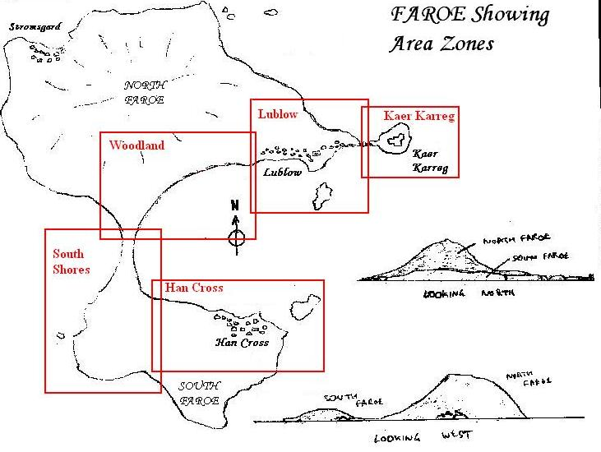
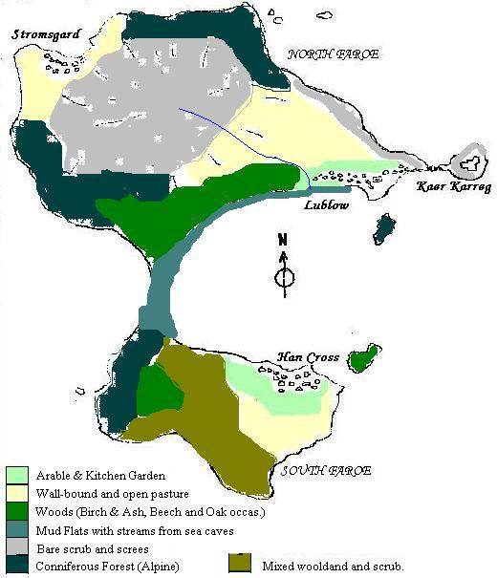
The story of Outcast takes place on the isle of Faroe, the southernmost and most isolated of the islands of Skellige. The whole island is ruled by jarl Harald, and comprises of 3 main villages as well as the keep at Kaer Karreg. There are several clans on the island, mostly clustered in a particular village. The village of Stromsgard will not feature in Outcast.

Kaer Carreg
Description: Kaer Carreg is the seat of Lord Harald, and perches on a natural promontory that is slightly separated from the island and reached via a bridge. Kaer Carreg is a wood and stone 'castle', consisting of a stone tower and several buildings that house Harald, his family and household.
Kaer Carreg is functional, housing the household, a kitchen, a great hall and a small armoury. Living quarters are sparse: Harald has a small study/library attached to his quarters (shared with his wife Gisla), whilst Astrid, Sven and Ragnar have rooms of their own. The rest of the household sleep within a curtained area of the Great Hall.
Schematic:

Scale Drawing:
Back To Top

Lublow

Description: The village of Lublow has been built on the sea shore on the more sheltered side of North Faroe, looking across Uist Bay. The village itself is on the top of a cliff that runs along the north shore of the bay. The ground rises running north-west to Mount Skarrak, and even the fields and cemetery are not particularly flat. The main track leads west and around the bay until it eventually passes through Han Cross on the other side, but Geralt can also take a boat across the lake between the two villages.

The village contains stores, a Sanctuary and an inn, and at the eastern end finishes in a walled cemetery. The village is not safe at night, particularly near the river/ford, and in the cemetery.

The mud flats leading from the docks to the waterfall also are haunted by creatures from the bay at night. Possibly there is a way into the cave system behind the waterfall.
Schematic:
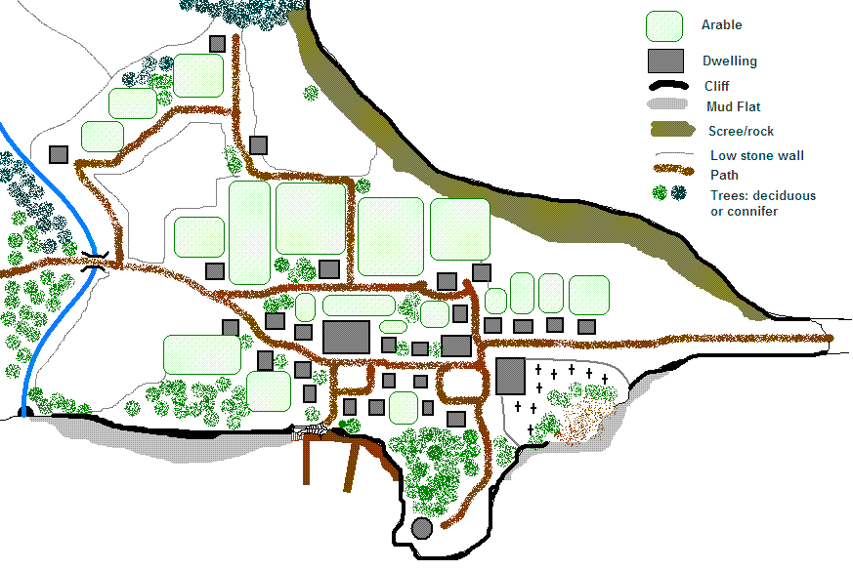
Showing unwalkable area:
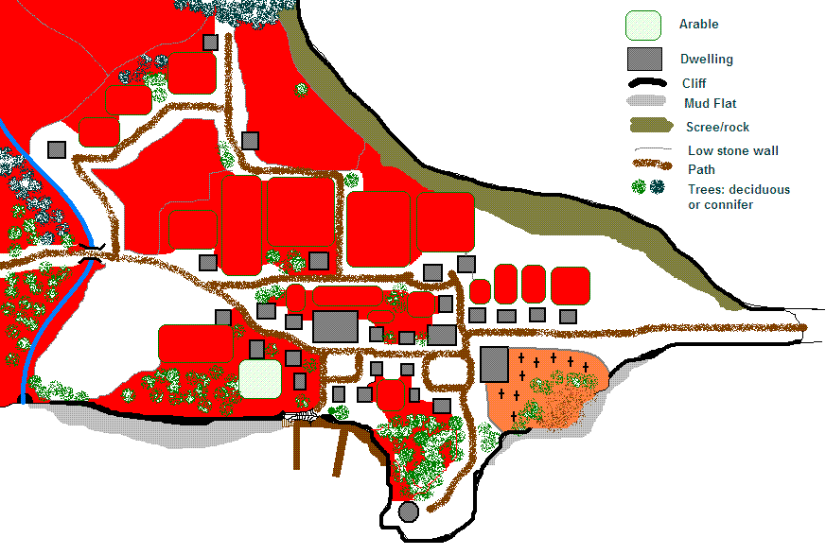
Scale Drawing:
Back To Top
Woodland
Description: This area is wild, consisting of patchy woodland, caves and rocky outcrops of Mount Skarrak that dominates Faroe. It is the main area for quests, housing ruins, elven hideouts and caves. The area stretches along the north/western shore of Uist Bay and is bounded to the north by Mount Skarrak itself, and to the east by the sea (and the west denser forest). A large expanse of mud flats and reed beds extend along the shore, and for much of the shoreline they back onto limestone cliffs with caves in them that discharge small streams across the flats. A path runs along the cliff tops, from Lublow up until the mud flats that separate North Faroe from South. Here stands an old tower which is used as a quarantine post until Act II. Tucked into the woods is a druid circle.
Schematic:
Scale Drawing:
Back To Top
Southern Shores
Description: This area is wild, consisting of a mixture of terrain. The northern end is a narrow bar of mud flats that joins South Faroe to North. From here, a path runs along the shoreline to Han Cross. The shore itself is still bounded by mud flats, but there are no cliffs here. On the western shore, cliffs prevail, topped by coniferous forest. This forest gives way to ash, birch and beech moving east, in a more sheltered glen that houses Shiltzen. Further east the land becomes more exposed and the forest gives way to scrub and copse, and eventually the pastures of Han Cross.
Schematic:
Scale Drawing:
Back To Top
Han Cross
Description: Han Cross, originally known as Han's Crossing, is a small linear village that lies on the opposite side of the lake from Lublow. There is an inn, stores and a Great Hall here (maybe a mill too). Most of the settlement is strung out along the road, but some paths may lead into the fields to farms. Another notable feature of Han Cross is the stretch of mud flats leading west along the lake shore.
Lublow can be reached by boat from the dock, or the Southern Shores area can be entered either via the path running west or by walking along the mud flats. The mud flats should in places give way to reeds or marsh (and can be re-applied from Act III or Act IV).
Shrines to the vodyanoi can be found on the island off the coast(?)
Schematic:
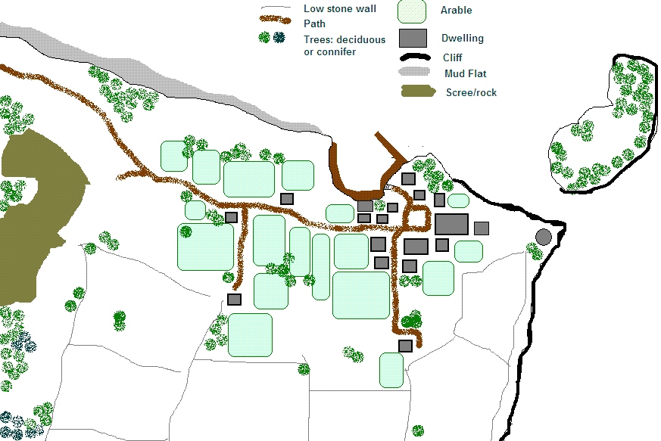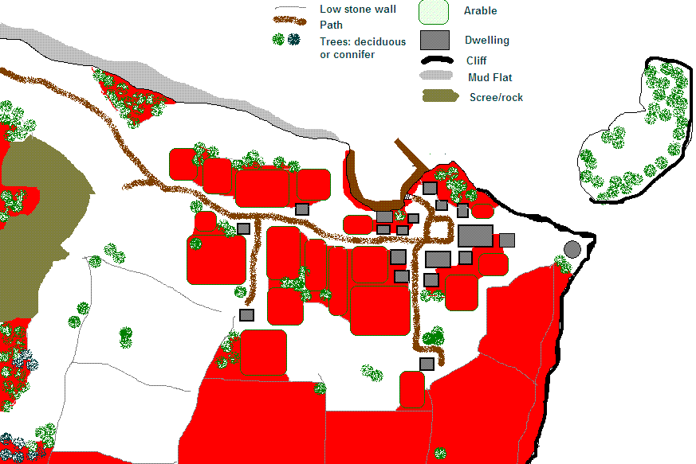
Scale Drawing:
Back To Top

Build Order (Ben, Martin)
Available from Act I
Sanctuary interior (Lublow)
Lublow
rest Lublow interiors
Kaer Karreg
Kaer Karreg interiors
Woodlands
Elven dwelling interiors (if any)
Available from Act II
Han Cross (Ferry opened)
Han Cross interiors
Southern Shores (Quarantine post opened)
Island (if needed)
Available from Act III
Shiltzen's House interior
Shiltzen's House area

Back To Top

Resources
The resources section includes the required resources. In most cases a separate brief is raised either formally or informally for the required resource. Recorded here is only minimum details, any technical data tracked, build order and required date.

Structures (Ben & Martin)
 | Structure | Area | Notes | Briefed | Complete by
1 | Sanctuary | Lublow | New model
2 | Houses | Lublow & Han Cross | Mixture of new and retextured models
3 | Inn | Lublow | New
4 | Great Hall | Han Cross | New
5 | Defaced Elven shrine | Southern Shores | New?
6 | Round stone tower | Various | New?
7 | Damaged round stone tower | Woodland | New?
8 | Inn | Han Cross | Retexture?
9 | Forge/smithy | Han Cross | New
10 | Shiltzen's home | Shiltzen's home | New – a partially hidden dwelling with a high walled pen attacked where Hafnir grew up.
11 | Mill | Han Cross | New?
12 | Druid Circle | Woodlands | New?
13 | Longship | Lublow & Han Cross | New
14 | Merchantman | Lublow | New
15 | Boat | Lublow & Han Cross | Re-use?
16 | Low stone wall sections | Lublow & Han Cross | Used to border most fields (a la northern England)

Back To Top
Creatures (Ben & ?)
 | Creature | Notes | Briefed | Complete by
1 | Hafnir | See Hafnir's design thread: http://www.dladventures.com/forum/vB/showthread.php?t=7976
2 | Forktail | Dragonlike creature of about twelve feet long with a forked tail.
Back To Top
NPCs (Ben & ?)
 | NPC | Notes: http://www.dladventures.com/forum/vB/showthread.php?t=8328 | Briefed – Who? | Complete by
1 | Ylva | http://www.dladventures.com/forum/vB/showthread.php?t=8429 & Description
2 | Harald | Description – new model. http://www.dladventures.com/forum/vB/showthread.php?p=50157 | Yes – Sascha
3 | Astrid 1 | New unmasked head, new combat body, new Masked head. Our heroine has concept art already done. Description. | Yes - Concept art done.
4 | Ingrid | New pregnant body model. Ingrid is a young pregnant girl. We need a pregnant pheno for her. Description. | No
5 | Gisla | New model – Description. http://www.dladventures.com/forum/vB/showthread.php?t=8429 | Yes
6 | Kara | Use existing. Woman in her mid twenties, should look somewhat exhausted and hungry, but make use of what exists. Description. | No
7 | Runa | Use existing. Late 20s, worn down by the memory of giving birth to a monster, and hates everyone because she fears they will discover it. Should look somewhat exhausted and hungry, but make use of what exists. Description. | No
8 | Urszula | New? Descritpion | No
9 | Ellevander | Use existing. Elven bandit leader – use pre-existing model (Yaeven?) | No
10 | Myrun | Use Astrid's combat body (modified?) and slightly modified Masked head. The decoy Masked Woman requires a masked head. This should be a retouched version of Astrid's. Myrun has long black hair, and was considered beautiful until she spent 6 years in the wild. She is slim, almost gaunt; tall and tough. | No
11 | Ljufa | Re-use existing head, beggar body? Ljufa has been forgotten and become a beggar in the village since she gave birth to a monster. She is suffering malnutrition, her body is skeletal, her clothes rags, and her face sunken. Her hair was straw coloured perhaps, but is filthy so it's difficult to tell now. Her eyes are brown, and she is about 28, though she looks older. | No
12 | Bjorn | Re-use existing. The smith of Han Cross. | No
13 | Astrid 2 | New semi-nude body. | In development - Alex
14 | Shiltzen | New head, body? The gnomish alchemist. A bookish type. Use the gnome head already in development. http://www.dladventures.com/forum/vB/showthread.php?t=8429 | Yes - Sascha
15 | Hunt Master | Re-use existing.
Back To Top
Placeables (Ben & ?)
 | Placeable | Notes | Briefed | Complete by
1
2
3
Back To Top

Technical Information
Perforce use (?)
Back To Top
Mantis (JP)
Back To Top
Folder Structures (Martin)
Back To Top
Naming conventions (Martin, Deva, Ben)
Back To Top
Workflows (All leads)
Project Workflow (Rob)
Overall milestones required here…

Workflow to Alpha:
- Exterior basics with a working geom.
- Area's interiors with a working geom.
- All transitions in place
- All spawnsets in place (including action points et al)
- Attach dialogues to creatures
- Build quests in quest editor
- Attach gap filling scripts
- Test
Back To Top
Building Workflow (Deva?)
Back To Top
Quest Workflow (Ben)
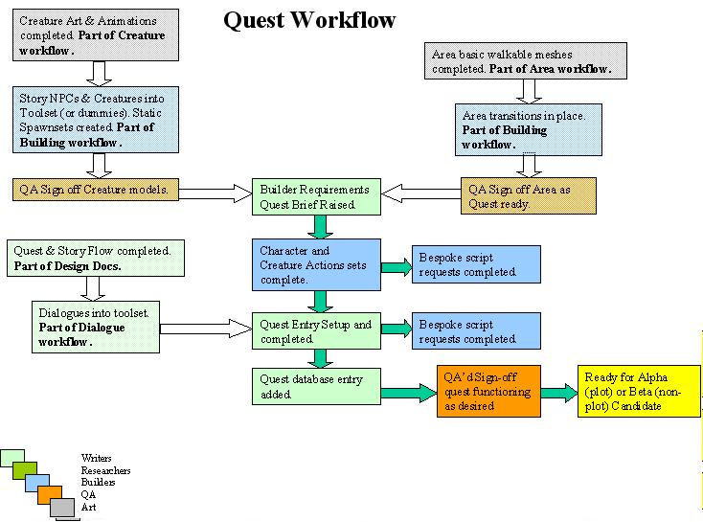
Back To Top
Cutscene Workflow (Adam)
Back To Top
Dialogue workflow (Ben)
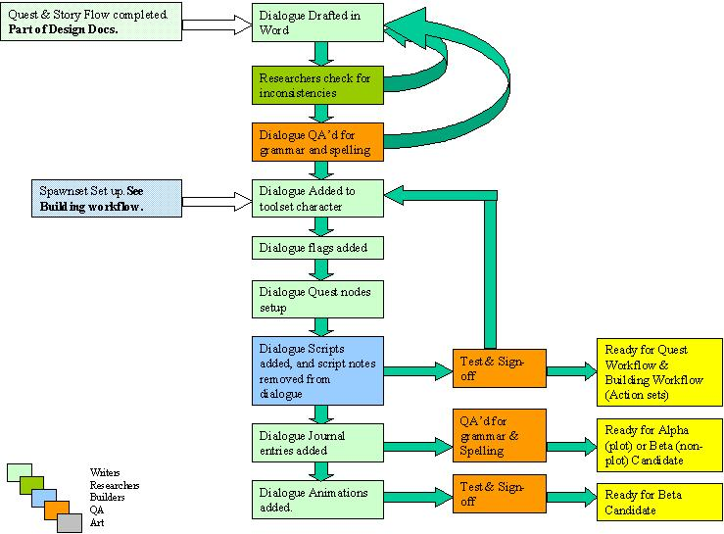
Back To Top
Area Builds (Martin)
Back To Top
Creature Models (New) (?)
Back To Top
Creature Models (Rebuilds) (?)
Back To Top
Placeables (?)
Back To Top

